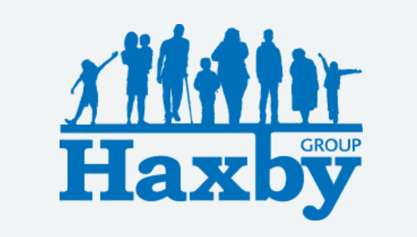
Our Haxby Group Newsletter
York edition
October 2026
Welcome to our monthly newsletter. This newsletter is available on our website and in our waiting rooms as physical copies. Key information will appear on our new Facebook page soon.
Flu and Covid Vaccination Clinics
We are holding flu and covid vaccination clinics this month in Haxby/Wigginton, Huntington, Acomb and Poppleton. If you are yet to book, please get in touch as we may have cancellations and appointments available at these sites. Thank you to all vaccinators and stewards who are helping to make this happen.

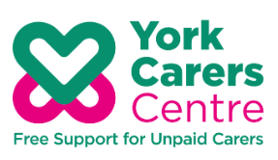
Save the date: Carers Information Fair
York Carers Centre is holding a Carers Information Fair for Carers Rights Day on Thursday 19 November to inform and empower unpaid carers about their legal rights, entitlements, and available support services.
The event is free and you can drop in any time from 1pm - 5pm.
Hosted at the Friargate Quaker Meeting House in York, the day will feature a packed programme of presentations and information stalls from organisations including the Alzheimer's Society, Dementia Forward, Mental Health Wellbeing Hubs, the Income Services Team, and City of York Council's Adult Social Care team.
When: Thursday 19 November, 1 pm - 5 pm
Where: Friargate Quaker Meeting House, York, YO1 9RL

Find our website here: www.haxbygroupyork.nhs.uk

Baby Loss Awareness Week is this month (9-15 October 2026)
Wave of Light is an event during the week – it is a global event which marks the end of Baby Loss Awareness Week where people light a candle at 7pm local time.

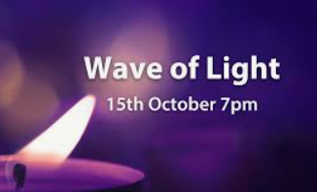

Flowers for the Fallen – crafting, tea and coffee drop in – everyone welcome

As Remembrance Sunday is approaching fast, Flowers for the Fallen are hosting a crafting, tea and coffee drop in at Haxby and Wigginton Health Centre on Friday 23rd October 9am - 12 lunchtime.
Flowers for the Fallen is a volunteer community initiative in York that places surplus supermarket flowers on forgotten service personnel graves and decorates local war memorials with handmade knitted poppies. Everyone is welcome to come along and join in with a cuppa and a biscuit!

NHS App updates on referrals

We use an electronic referral service (e-RS) to transmit most of our referrals to secondary care services.

Patients using the NHS App will start to receive notifications and updates relating to their e-RS referrals. This will include confirmation that their referral has been received and information about what is happening with it next.

We would encourage patients requiring referral to download and use the NHS App, as you will be able to view updates and track the progress of your referral through the app (as well as all the other helpful features to manage your care).

Thank you for reading. If you would like to join our Patient Participation Group either as an organisation or as an individual, to help shape and improve the care we can provide, please let us know at:
hnyicb-ny.haxbypatientexperience@nhs.net

We are holding our next Patient Participation Group in October 22nd at 6pm at
Gale Farm Surgery in Acomb. All welcome.

