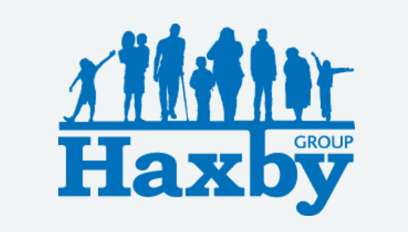
Our Haxby Group Newsletter
York edition
August 2026
Welcome to our monthly newsletter. This newsletter is available on our website and in our waiting rooms as physical copies. Key information will appear on our new Facebook page soon.
York 10km

A huge well done to everyone who ran the York 10km this weekend and to those who represented Haxby Group in support of Cancer Research UK!

On Sunday, our team took on the York 10K, following another fantastic effort from our Haxby colleagues who got wonderfully muddy at the Hull Pretty Muddy event the previous weekend!

We're incredibly proud of everyone who took part, fundraised and supported such an important cause. Every step, every splash and every donation helps bring us closer to beating cancer.

Feedback

We take many forms of feedback about our services – Google Reviews, form via SMS following your appointment, patient surveys, feedback forms in the waiting room, patient experience contacts via our website, to name a few – and analyse this feedback, including compliments and complaints, to consider how we can adapt and improve. A patient survey will be coming out soon to those patients who have accessed our services in the past 12 months; please take the time to complete this if you are able.

Some stats from our form sent via SMS following your appointment for July: 836 responses – 93% of patients stated that they had a good or very good experience with us (83% very good); 94% were satisfied or very satisfied with their appointment and 93% had a good or very good experience of getting an appointment. We appreciate this doesn't account for everyone's experience and we take account of all feedback.

Save The Date!
Following a Veteran's event that we held in June, we will be holding a Carer's drop in event on September Friday 23rd at lunchtime – surgery TBC. This will be an informal session to come along and say hello; care recipients also welcome. We are looking for further dates to invite veterans in again too.

How to stay safe in the sun: wear a hat, wear sunglasses, drink plenty of water, use the shade and wear suncream factor 30+.

If you notice any skin changes, please contact us for advice.

Understanding who you are seeing:
A large proportion of our appointments are delivered by our GP partners and salaried GPs in our surgeries. Sometimes you may see another clinician. All appointment requests are assessed by an experienced duty GP to determine the most suitable clinician and time frame for each individual case.
Some of our roles are:
GPs (general practitioners) are doctors who have completed training in general practice. They have the knowledge and skills to manage many of your health issues and are also able to refer to other specialities.
Advanced Clinical Practitioners (ACPs) are healthcare professionals with advanced clinical skills from various backgrounds e.g. paramedics. They play a crucial role in patient care, working alongside doctors and other healthcare professionals. Their responsibilities include assessing patients, diagnosing conditions, prescribing medications, and managing treatment plans, ultimately contributing to improving patient outcomes and healthcare services. Our ACPs support our GPs in visiting care homes.
The Nursing Team consists of various health care professionals including Practice Nurses and Health Crae Assistants. They are a highly skilled team who provide a variety of services including immunisations, diagnosing, and managing long term conditions, family planning advice, cervical screening as well as travel assessment and vaccines. They enable patients to maintain healthy lifestyles through a variety of interventions using a patient-centred approach. HCAs perform much of our blood taking, ECG and annual review appointments.
Social Prescribers can assist with various emotional and practical issues affecting your health and well-being. They know local support services and groups and can help connect you to activities that promote positive changes to your health.
Physiotherapists assess, diagnose, and treat people with physical disabilities or injuries, helping to improve range of motion, strength, balance, and coordination. They also work with patients to manage pain, balance, mobility, and motor function.
Thank you for reading. If you would like to join our Patient Participation Group either as an organisation or as an individual, to help shape and improve the care we can provide, please let us know at:
hnyicb-ny.haxbypatientexperience@nhs.net

We are planning to hold our next Patient Participation Group is TBC.

