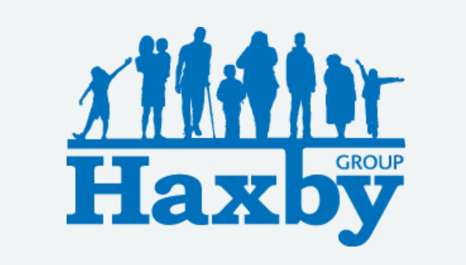
Our Haxby Group Newsletter
York edition
May 2026
Welcome to our monthly newsletter. This newsletter is available on our website and in our waiting rooms to read as physical copies.

Health

🌸 Pollen allergies? Start antihistamines early and keep windows closed on high pollen days. Your pharmacist can give advice on managing symptoms.

🩺 Bowel cancer is one of the most common cancers, but it’s treatable if caught early. If you’re aged 50-74, you will receive a free NHS screening kit in the post - don’t ignore it! If you have any concerns, speak to your GP.


Haxby Group Website

When using our website, you’ll notice some words are bold and underlined. These are links that take you straight to the page you need. For example, to make an appointment, click on Appointments on the main page. Scroll down to Request an Appointment where you will see another link: online tool. This online tool is called Klinik and it allows you to submit an online appointment request, which goes straight to one of our doctors, as do appointment requests made at reception desks and over the phone. Klinik opens from 7am until 6pm Monday – Friday, excluding bank holidays; general enquiries and other admin requests can be made be made via Klinik too, including updating your address or phone number.

We will be closed Monday 4th May and Monday 25th May this month for the bank holiday breaks. We reopen on both occasions at 8am the following Tuesday mornings.

May welcomes in Mental Health Awareness Week!

This will take place from May 11th – May 17th. The Mental Health Foundation has been leading this week since 2001, bringing together individual organisations and communities to improve mental health awareness.
This year's theme is 'Action'.
Why Action?
The Mental Health Org website states the following: We’ve chosen Action as this year's theme because, while awareness is vital, real change comes when we act too. Together, we’ve come a long way on mental health, but we can’t risk going backwards. There’s still much we can do to prevent people becoming unwell in the first place. Take Action for yourself, for someone else, for all of us. Haxby Group York will be supporting Mental Health Awareness Week by taking part in Wear It Green Day on Thursday 14th May.

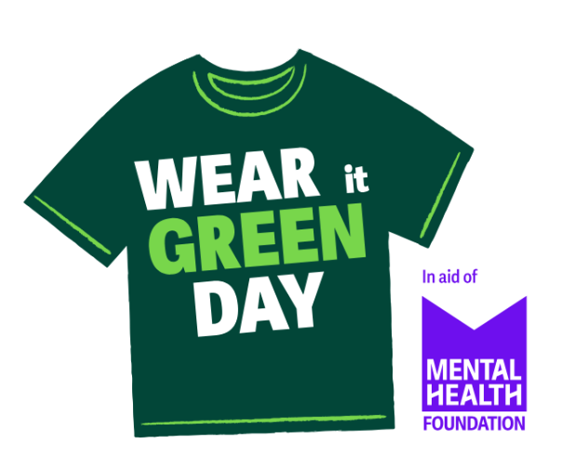

Aging Well Fair
On Friday 15th May, The Folk Hall in New Earswick is holding an Aging Well Fair from 10:30am–12:30pm for a friendly community event supporting healthy aging.
Slipper giveaway
Multiple healthcare partners on-site
Information, support, and advice
Open to all
Pop in, have a chat, and discover local services that can help you stay active, safe, and well. Michael, Patient Services Team Leader, will be on site to talk patients through the NHS App and other IT queries.

Haxby and Wigginton Scarecrow Festival
This year, we are taking part in the Haxby and Wigginton Scarecrow Festival which takes place Saturday 2nd – Monday 4th May 2026. The festival is fundraising for some fantastic charities: Candlelighters, Dementia Forward, Outreach EMR and Yorkshire Air Ambulance. If you can't see them in person, check out our scarecrow on our Facebook page – Haxby Group York! Thank you to Lisa, Patient Services Team Leader, and Dr Elizabeth Drury for organising our wonderful scarecrow!
Thank you for reading. If you would like to join our Patient Participation Group either as an organisation or as an individual, to help shape and improve the care we can provide, please let us know at: hnyicb-ny.haxbypatientexperience@nhs.net
The date for our next Patient Participation Group is TBC.
If you would like to contribute any ideas for future Newsletter editions, please also let us know at the above email address.

