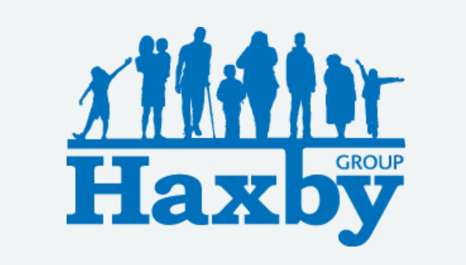
Our Haxby Group Newsletter
York edition
June 2026
Welcome to our monthly newsletter. This newsletter is available on our website and in our waiting rooms as physical copies.

Pharmacy First Scheme – Summer Months

Many pharmacists can help with various ailments without the need to speak to a GP and can prescribe for some conditions in some circumstances. Relevant summer conditions that your pharmacy can help with include treatment of insect bites and hay fever.

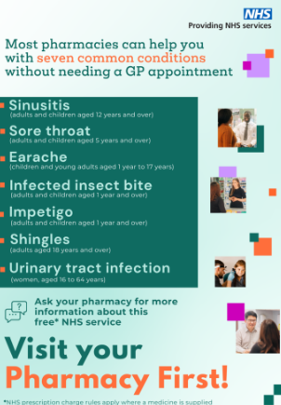

Blood Tests

In York, we have a range of options for blood taking. We have walk in blood taking services at York Hospital and the Community Stadium, Monks Cross. At Askham Bar, you can now use a walk in service or still make an appointment with Nimbuscare by calling 01904 943690. If you are unable to attend any of these options, please enquire with reception about the availability of appointments in our surgeries.

When attending a walk in service, you require an A4 form from us which contains a bar code that will be scanned at your visit. These can be collected from reception or may be handed to you during your appointment. Please note our receptions are all closed 12.30-13.30 for lunch and training.

Did you know? You can request appointments from 7am weekdays via our website. You can make general enquiries on the website, avoiding the phone queues or a trip to a surgery.

Safeguarding Week happens this month between the 15th and 19th in the York and North Yorkshire region. All members of our staff team have been invited to join various online learning events during this time to further expand our knowledge of services provided in our local area.

Better visibility of repeat medicines in the NHS App
Changes to the NHS App prescriptions feature gives patients a complete view of all their active repeat medicines.
Patients can now see all their repeat items in one place, including medicines that cannot be requested yet, with clear explanations of why, for example, if it’s too soon to order again, or a review is needed. This helps people better understand their medicines, and reduces the confusion where items previously appeared "missing". All TPP practices are now live with this feature, with Optum (formerly known as EMIS) practices rolling out from June.
For GP practices, this supports safer medicines use, reduces unnecessary requests, and helps cut prescription-related enquiries and administrative workload.
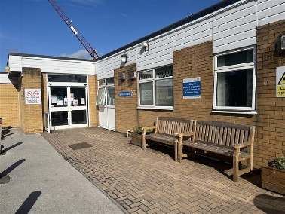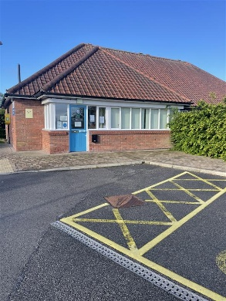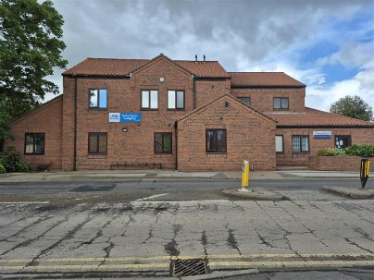
Google Reviews
We have recently updated the photos of our sites on our google review pages.
Did you know .... each of our 5 York surgeries has its own page? QR codes that take you directly to them are postered around our surgery waiting rooms and receptions.
We're always keen to hear from you if you wish to leave a review.
Please note that, whilst comments are responded to on our google review pages, if you wish to speak to us about individual circumstances you should please contact us directly via our website, phone or front desk.

Thank you for reading. If you would like to join our Patient Participation Group either as an organisation or as an individual, to help shape and improve the care we can provide, please let us know at: hnyicb-ny.haxbypatientexperience@nhs.net

We are planning our next Patient Participation Group – date and venue TBC.

If you would like to contribute any ideas for future Newsletter editions, please also let us know at the above email address.

